ASSIGNMENT 2: TEXT ANALYSIS OF PROPOSAL FOR GOOGLE

# Assignment 2 (Worth 50%)

Submission: **Tues 10th Dec, 11 am.** A 2500 word Report, associated Orange Workflows and Data files.

**This assignment requires you to develop a real-world text analytics solution that will be capable of instigating change in an organisation.  You have already participated in an organisational task from a group perspective, and have specified a project in CRISP-DM. You will now deliver a text analytic solution.**

Your task is to **adopt your provided project plan** and to pursue the text analysis that is specified**.** You are to perform the Data Preparation, Modelling and Evaluation as part of the CRISP-DM strategy prepared for Google as they seek to prepare for the best and worst issues that will arise, relating to a Google Pixel Phone that uses a LLM interface. You aim to support Google in understanding opportunities and threats that surround the project.

You are to submit a report to Google presenting **Four Text Analysis stories** that offer compelling evidence for adopting **Four different strategies**. The Four strategies are expected to be persuasive about a client group, or a client need, or a positive feature of LLMs, or negative features. For each you should tell a story that is aimed at helping Google to focus as it decides on what to do as it plans to invest an estimated $1billion to establish a Google LLM Pixel Phone.

**You are specifically asked to address pressing questions of sustainability and disruption as Google pursues a strategy. In doing so, you will help Google to reflect on important considerations they will need to be addressed before taking the proposals forward.**

## Text Analytics Project Specification

You are to lead Google decision-making by asking the company to focus 5 important themes that Google needs to address. The themes can be chosen from a range of relevant topics and sentiments brought up by previous users of Chat GPT who have given feedback. You can focus wholly on customer topics and sentiments as given in the feedback survey, or you can mix and match some of the survey observations with others that you consider important, perhaps from X or a Newspaper such as the Guardian. You should guide Google through key positives and the negatives that you discover, so that they can address both opportunities and threats and produce a winning product.

You are to design and develop a series of Orange Workflows of your choice for Google using Text Analytics implemented in Orange Data-Mining. In addition, you are to write a report that is to be supplied with the workflows and data in answer to the project brief. You are also asked for a brief set of user guidelines showing how to use the workflows.

Each theme you chose should be analysed, using the story-telling, and each analysis should be capable of leading Google decision-making.

**Submitted Report: Using The Storytelling Framework for each of your Four Analyses**  
You should produce a suitable report, as described in our materials on report writing. The Main Body of the report should have Four main sections, one for each of the analyses you have performed.

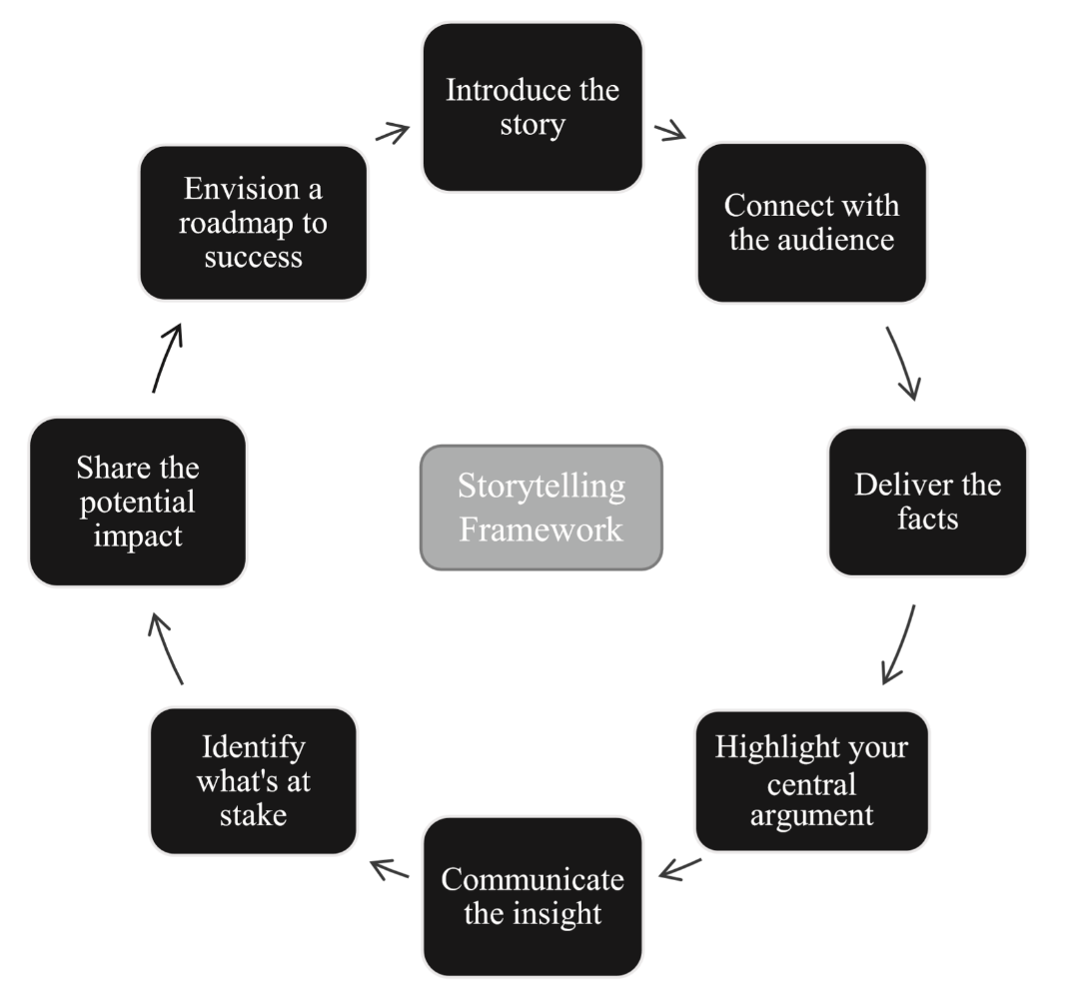

Figure 1: The Story-Telling Framework

## Four Orange Workflows

Your Orange work should contain four Orange Workflows, each of which should support one of your Text Analytics stories.

### Working with data

You should submit the Orange Workflows all associated data files along with your report in a zipped file.

## Tasks

1. Explain the importance of the story-telling framework in presenting the results of a text analytics project.
2. Perform three forms of text analytics on the dataset to uncover interesting observations from the dataset that has been given. Using the framework, present the results of your analyses to help inform Google policy.
3. Present your results in a 2,000 report that contains:
   1. Title Page
   2. Executive Summary
   3. Table of Contents
   4. Introduction
   5. A Main Body which includes
   * A section on Data Preparation
   * The Four Key Analyses, (some details may be placed in an appendix)
   * Use screen shots from your Orange Data-Mining work to highlight important points, provide
   * Key recommendations for each **narrative, and**
   * Evaluate if there are any pressing questions on disruption, sustainability, risk management, or data ethics that need to be addressed in each narrative.
   * A short user guide on how to use each of the workflows in Orange.
4. Recommendations and Conclusion, along with any necessary appendices.
5. Submit your **Orange files**, and any **Data Files**.

Archive all of the files together (using zip) and submit the archived file in Canvas. Upload your report on Canvas. If you wish to make changes to a submitted file, just re-submit the amended version. The file with the latest date will be marked.

Please keep a backup of your file. Further details of the marking criteria can be found on the marking sheet which is in the module outline.